**Driver Drowsiness Detection**

*A Major-project Report submitted in fulfillment of the requirements for*

*The award of the degree of*

**Master of Computer Applications**

By

**Aayush Barfa**

**(18419MCA001)**



**Department of Computer Science**

**Institute of Science**

**Banaras Hindu University, Varanasi – 221005**

**July 2021**

**CANDIDATE’S DECLARATION**

I **Aayush Barfa** hereby certify that the work, which is being presented in the Mini-project report, entitled **Social Distance Detection**, in fulfillment of the requirement for the award of the Degree of **Master of Computer Applications** and submitted to the institution is an authentic record of my own work carried out during the period January-2021 to July-2021 under the supervision of *Prof. Gourav Baranwal Sir*.

The matter presented in this Mini-project as not been submitted elsewhere for the award of any other degree or diploma from any Institutions.

Date: 15-07-2021 Signature of the Candidate

The Viva-Voce examination of *Aayush Barfa*, M.C.A. Student has been held on 19-07-2021.

Signature of the Supervisor

**ABSTRACT**

 Various studies have suggested that around 20% of all road accident are fatigue-related. This usually happens when a **driver** has not slept enough, but it can also happen because of untreated sleep disorders, medications, drinking alcohol, or shift work. Makes you less able to pay attention to the road. Slows reaction time if you have to brake or steer suddenly.

The main aim of this is to develop a drowsiness detection system by monitoring the facial expression; it is believed that the symptoms of driver fatigue can be detected early enough to avoid a car accident. Detection of fatigue involves the observation of eye movements and blink patterns.

**TABLE OF CONTENTS**

Title Page No.

ABSTRACT iii

LIST OF FIGURES v

1. **INTRODUCTION**  6
2. **LITERATURE REVIEW** 7
3. **PROPOSED APPROACH** 8
4. **IMPLEMENTATION**
5. Facial Landmark Marking 9
6. Ration Computation 10
7. Controlling the Alarm 11
8. **RESULTS AND DISCUSSION** 12
9. **CONCLUSION AND FUTURE WORK** 13

**REFERENCES**  14

**LIST OF FIGURES**

**Figure No.** **Title** **Page No**.

* 1. Facial Landmark Points according to Face reorganization library. 9

4.2 Points near eye region 10

4.3 Points near mouth region 10

5.1 Detecting Drowsiness when eyes closed 12

5.2 Yawn Detection when mouth is wide open 12

**CHAPTER 1**

**INTRODUCTION**

One of the major causes behind the casualties of people in road accidents is driver’s drowsiness. After continuous driving for long time, drivers easily get tired resulting into driver fatigue and drowsiness. Research studies have stated that majority of accidents occur due to driver fatigue. Different countries have different statistics for accidents that occurred due to driver fatigue. Developing technology for detecting driver fatigue to reduce accident is the main challenge. According to the report by “Ministry of Road Transport & Highways” there were 4,552 accidents reported every year in India that took lives of thousands of people because of sleepy drivers (Road Accidents in India 2016). For instance, many vehicles are driven mostly at night such as loaded trucks. The drivers of such vehicles who drive for such continuous long period become more susceptible to these kinds of situations. Detecting drowsiness of drivers is still an ongoing research in order to reduce the number of such miss-happenings and accidents. Typical methods used to identify drowsy drivers are physiological based, vehicle based, and behavioral based**.** Physiological methods such as heartbeat, pulse rate, and Electrocardiogram etc. are used to detect fatigue level. Vehicle based methods include accelerator pattern, acceleration and steering movements. Behavioral methods include yawn, Eye Closure, Eye Blinking, etc. To encounter this worldwide problem, a solution that captures images in a succession, transmits real-time driver’s data to the server, and determines drowsiness using EAR (Eye Aspect Ratio) and yawn ration has been proposed and implemented. The computed value via the system prompts the driver through alarm to take a break or rest for some time.

**CHAPTER 2**

**LITERATURE REVIEW**

1. Driver drowsiness detection is a car safety technology which helps to save the life of the driver by preventing accidents when the driver is getting drowsy.
2. The main objective is to first design a system to detect driver’s drowsiness by continuously monitoring the eye and mouth.
3. The system works in spite of driver wearing spectacles and in various lighting conditions.
4. To alert the driver on the detection of drowsiness by using buzzer or alarm.
5. In both condition EAR(Eye Aspect Ratio) and yawn detection there are two different alarm will be buzzed.

**CHAPTER 3**

**Proposed Approach for Driver Drowsiness Detection**

This section details the proposed approach to detect driver’s drowsiness. First, we’ll set up a camera that monitors a stream for faces. The process starts with capturing of live images from camera and search for face. If a face is found Face Recognition Library is employed to detect facial landmarks and a threshold value is used to detect whether driver is drowsy or not. These facial landmarks are then used to compute the EAR (Eye Aspect Ratio) and Yawn Ration the both the computed value be compared with the threshold value taken as 0.25 for EAR and 25 Yawn Ration. If the EAR value is less than the threshold value and if yawn ration is more than threshold limit then any of this would indicate a state of fatigue. In case of Drowsiness, the driver and the passengers would be alerted by an alarm. The subsequent section details the working of each module. After that alarm will be automatically stops when driver gets out of that situation.

**CHAPTER 4**

**Implementation**

**4.1 Facial Landmark Marking**

To extract the facial landmarks of drivers, Face Recognition library was imported which is Built using dilb’s state-of-the-art face recognition built with deep learning. The library uses a pre-trained face detector, which is based on a modification to the histogram of oriented gradients and uses linear SVM (support vector machine) method for object detection. The model has an accuracy of 99.38%. Actual facial landmark predictor was then initialized and facial landmarks captured by the application were used to calculate distance between points.

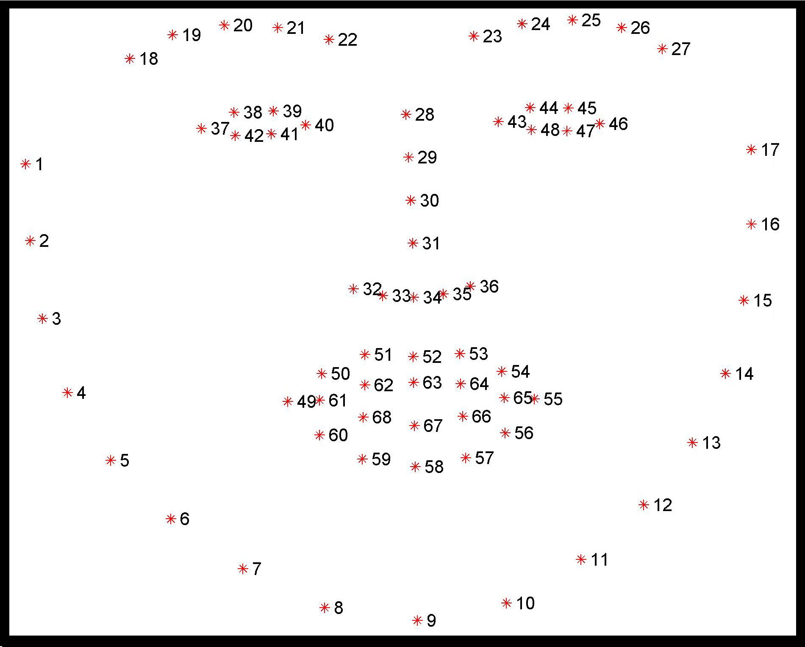

Fig. 4.1 -Facial Landmark Points according to Face reorganization library.

**4.2 Ration Computation**

The distance we calculated using facial landmark points (fig. 2 and fig. 3) is used to compute EAR value and Yawn ration.

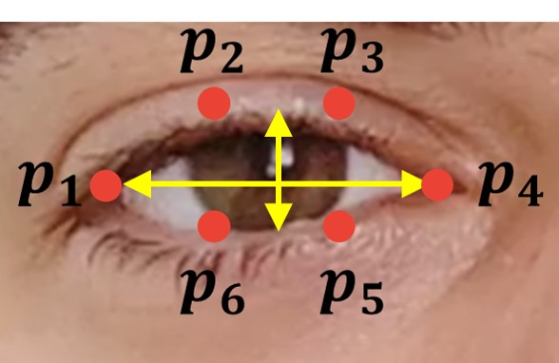

Fig. 4.2 –Points near eye region.

Using these points as shown in fig. 2 we compute Euclidean distance between 𝑝2 and 𝑝6 store in A, 𝑝3 and 𝑝5 store in B, 𝑝1 and 𝑝4 store in C.

So EAR = (A + B) / (2.0 * C) Or in other words EAR = (|𝑝2 – 𝑝6| + |𝑝3 – 𝑝5|)/ (2 ∗ |𝑝1−𝑝4|).

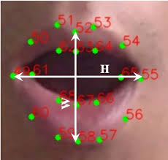

Fig. 4.3 –Points near mouth region.

Using these points as shown in fig. 3 we can compute the Euclidean distance between mean of the upper lip and lower lip points which is used for comparison with threshold limit.

**4.3 Controlling the Alarm**

The camera Captures 30 images per second and the process shown above keeps repeating itself till it is not manually stopped. When we gets rations, it is compared with threshold limit for EAR (Eye Aspect Ration) threshold limit is .25 and for Yawn detection Threshold limit is 30.

Both the threshold limit can be adjusted based on driver face, for example East Asian people have small eyes so they can decrease the threshold limit. If EAR value decreases compared to threshold it means driver eye is closing and so counter starts automatically. If eyes does not open in specified time (this is also adjustable) which is 5 seconds then it will automatically trigger the alarm and as EAR increases compared to threshold alarm stops it means driver is again awake. Similarly yawn is detected when yawn ration is increases compared to threshold it gives single beep alarm instantly to give notice to the drives about yawn. Yawn is a symptom of boredom which results in drowsiness.

**CHAPTER 5**

**Results and Discussions**

This sections tells about outcome of Driver Drowsiness Detection .

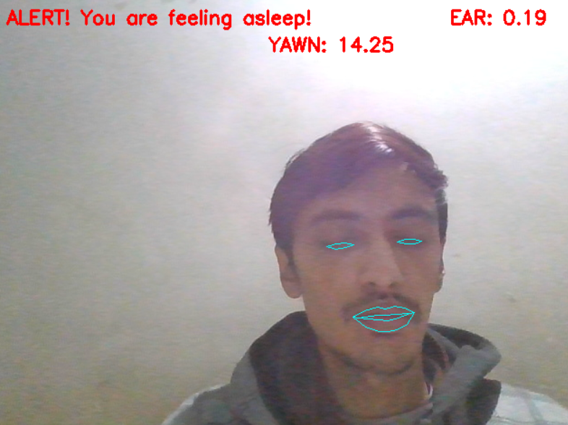

Fig. 5.1 –Detecting Drowsiness when eyes closed

As we can see in Fig. 4 Eyes are closed and thus EAR is decreased which is less then threshold limit so it is showing “Alert!” to notify the driver. This alert is not for Yawn Detection as mouth is not wide opened thus yawn ration is calculated is less then threshold limit.

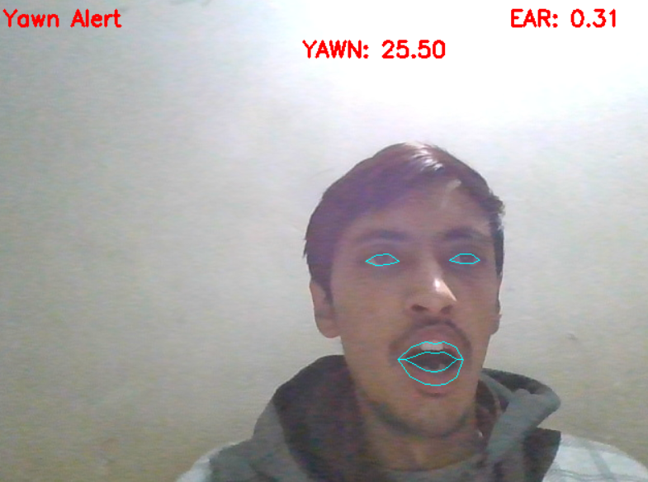

Fig. 5.2 –Yawn Detection when mouth is wide open

Now in Fig. 5 it is showing yawn alert as yawn ration is exceeded by threshold limit and in Fig 5 we can notice EAR is more than Ear threshold as eyes are open.

**CHAPTER 6**

**Conclusion and Future work**

In this work, a real time system that monitors and detects the loss of attention of drivers of vehicles is proposed. The face of the driver has been detected by capturing facial landmarks and warning is given to the driver to avoid real time crashes. Non-intrusive methods have been preferred over intrusive methods to prevent the driver from being distracted due to the sensors attached on his body. The proposed approach uses Eye Aspect Ratio and Yawn Detection to detect driver’s drowsiness in real-time. This is useful in situations when the drivers are used to strenuous workload and drive continuously for long distances.

The future work can include integration of the proposed system with globally used applications like Uber and Ola. The system, if integrated, can reduce the number of casualties and injuries that happen regularly due to these drowsy states of the drivers. This experiment can run as a part of pilot plan i.e. for a few days/months in different regions of the world where such incidents occur regularly. It gives the same accuracy for the people wearing spectacles. Accuracy of our proposed system improves with the increase in brightness of the surrounding environment. The work can be extended for different types users such as bike riders or in different domains like railways, airlines etc.

**REFERENCES**

* “Road Accidents in India 2016,” 2016.
* S. Sangle, B. Rathore, R. Rathod, A. Yadav, and A. Yadav, “Real Time Drowsiness Detection System,” pp. 87–92, 2018.
* V. Varghese, A. Shenoy, S. Ks, and K. P. Remya, “Ear Based Driver Drowsiness Detection System,” vol. 2018, pp. 93–96, 2018.
* Kumar and R. Patra, “Driver drowsiness monitoring system using visual behaviour and machine learning,” ISCAIE 2018 - 2018 IEEE Symposium on Computer Applications and Industrial Electronics, pp. 339–344, 2018.
* Sukrit Mehta, Sharad Dadhich, Sahil Gumber, Arpita Jadhav Bhatt, “Real-Time Driver Drowsiness Detection System Using Eye Aspect Ratio and Eye Closure Ratio”.
* T. Hwang, M. Kim, S. Hong, and K. S. Park, “Driver drowsiness detection using the in-ear EEG,” Proceedings of the Annual International Conference of the IEEE Engineering in Medicine and Biology Society, EMBS, vol. 2016–Octob, pp. 4646–4649, 2016.
* S. Junawane, S. Jagtap, P. Deshpande, and L. Soni, “Driver Drowsiness Detection Techniques : A Survey,” vol. 6, no. 11, pp. 2015–2017, 2017.
* R. Jabbar, K. Al-Khalifa, M. Kharbeche, W. Alhajyaseen, M. Jafari, and S. Jiang, “Real-time Driver Drowsiness Detection for Android Application Using Deep Neural Networks Techniques,” Procedia Computer Science, vol. 130, pp. 400–407, 2018.